HarvestHub: AI-Driven Platform for Crop Selection, Price Prediction & Farmer Assistance

In propose work we have implemented Random Forest algorithm to predict suitable crops based on season and soil conditions. Experienced farmer can input model with Nitrogen, Phosphorus and Potassium. LSTM algorithm is employed to predict prices which can help farmers about current market prices.

We have included CHATBOT to assists farmers for his questions and this CHATBOT can reply to farmer in English and Telugu language. We don’t have other language keyboards from input so we are generating response in both English and Telugu language

To train above algorithms we have used crop recommendation and CHATBOT question and answers dataset.

To implement this project we have designed following modules

1. New user sign up: user can sign up with the application
2. User Login: user can login to system
3. Load & Process Dataset: using this module will upload and process dataset and then split dataset into train and test where application using 80% dataset for training and 20% for testing
4. Train ML Models: 80% processed data will be input to algorithms to train a model and this model will be applied on 20% test data to calculate prediction accuracy
5. Crop Recommendation: using this module user can input soil details, season and other values to predict suitable crop along with prices
6. Chatbot: user can ask question and then Chatbot will reply answer

SCREEN SHOTS

To run project install python 3.7.2 and then install all packages given in requirements.txt file and then install MYSQL and copy content from DB.txt file and paste in MYSQL console to create database and now double click on run.bat file to get below page

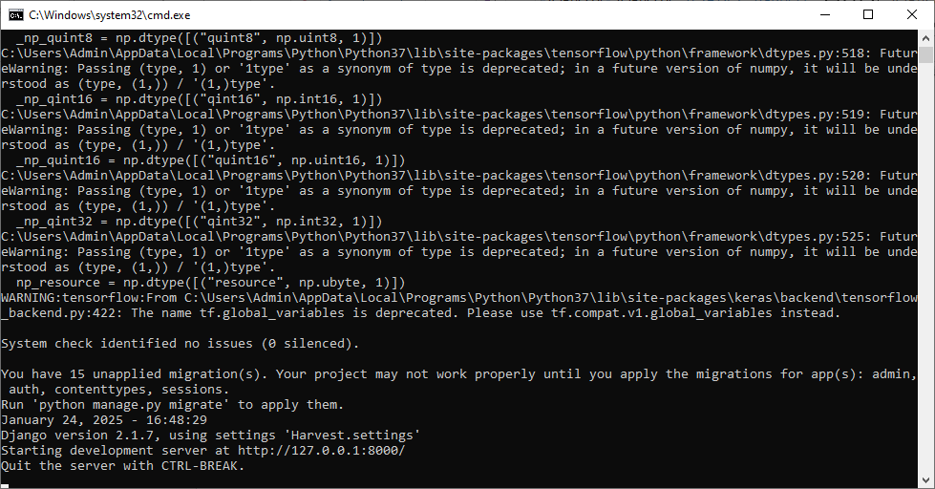

In above screen python server started and now open browser and enter URL as <http://127.0.0.1:8000/index.html> and then press enter key to get below page

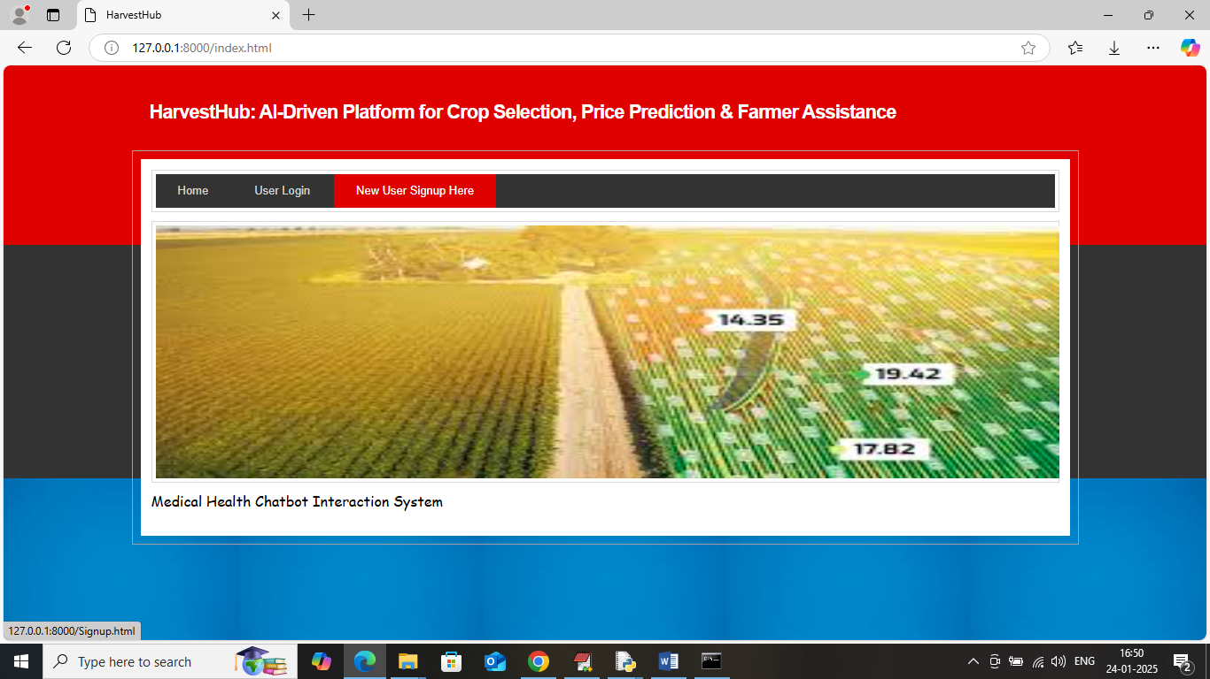

In above screen click on ‘New User Sign up’ link to get below page

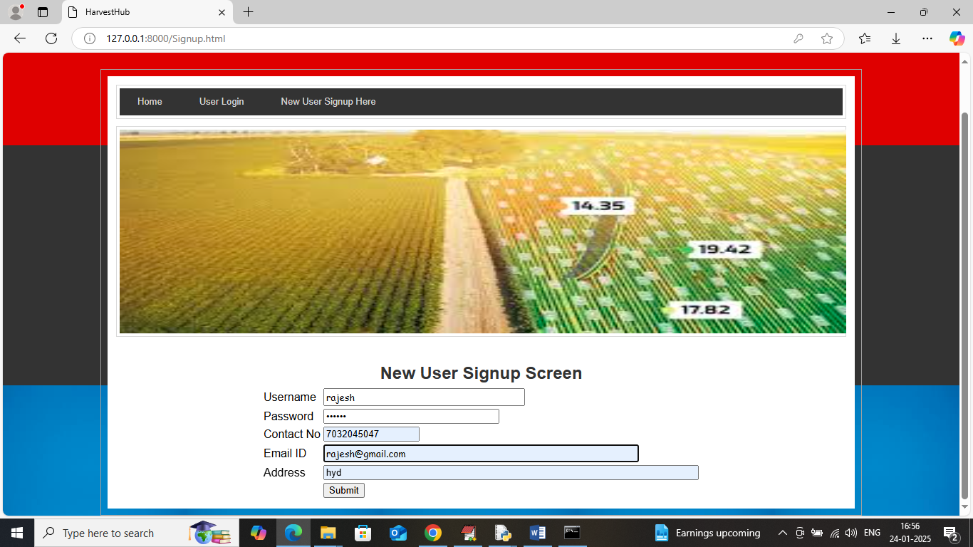

In above screen user is entering sign up details and then press button to get below page

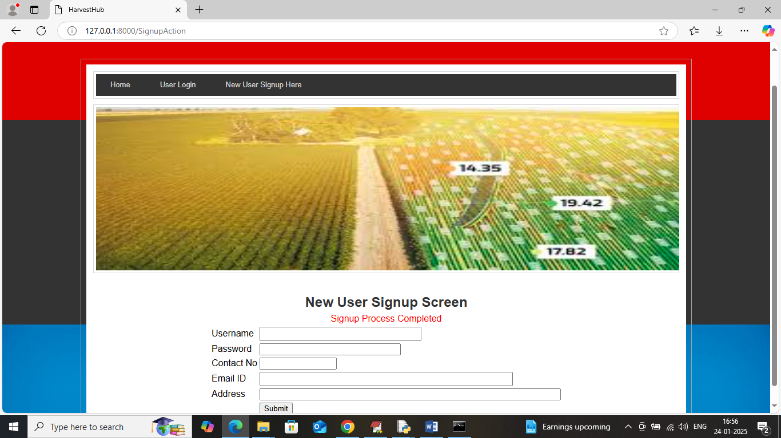

In above screen user sign up completed and now click on ‘User Login’ link to get below page

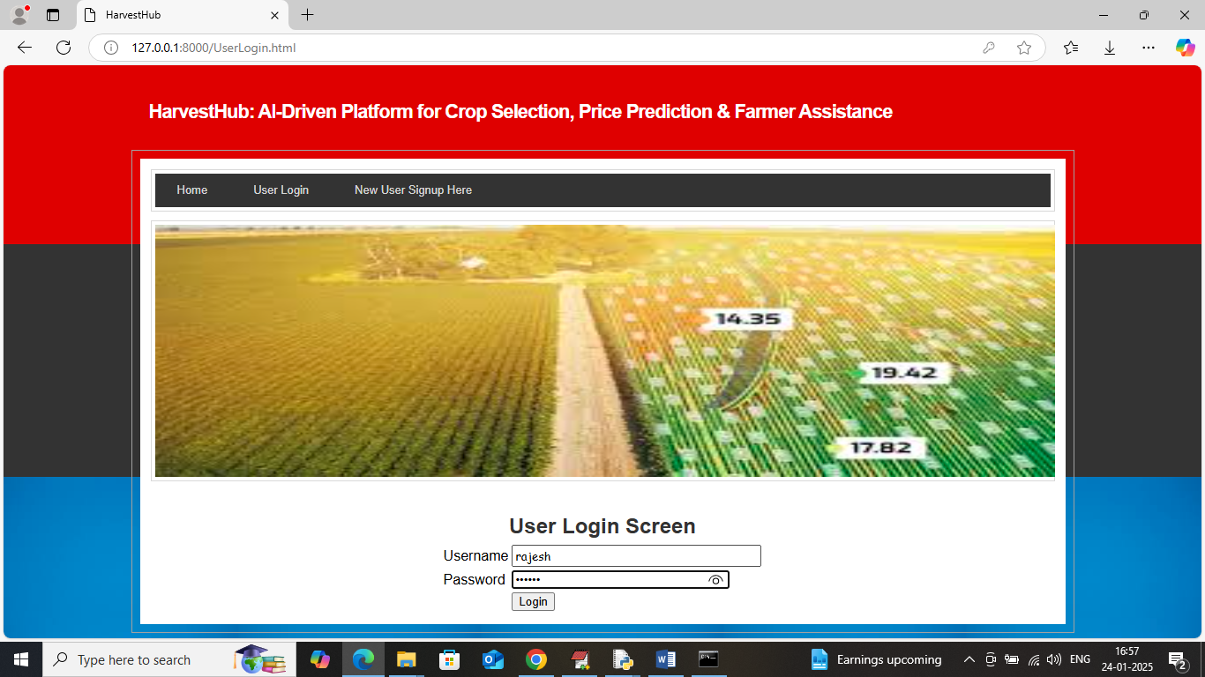

In above screen user is login and after login will get below page

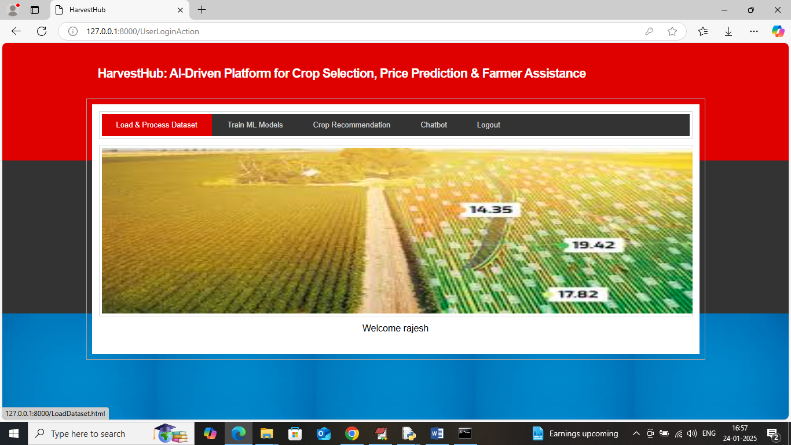

In above screen click on ‘Load & Process Dataset’ link to get below page

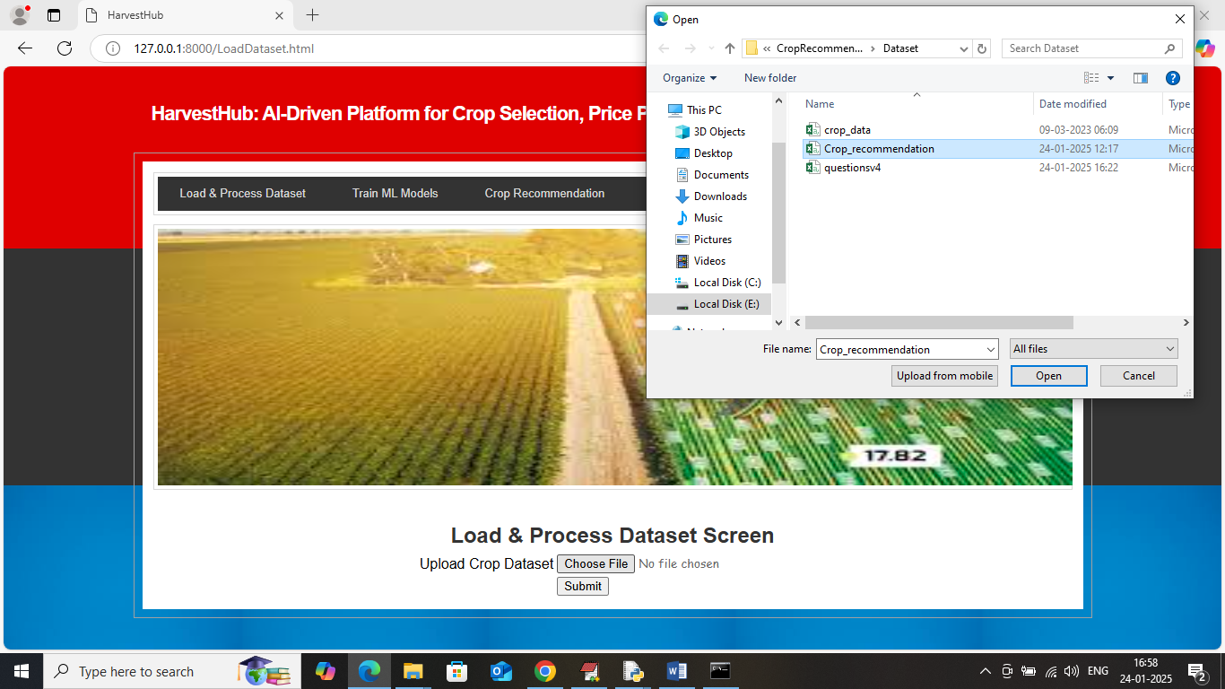

In above screen selecting and uploading ‘crop’ dataset and then click on ‘Open and submit’ button to get below page

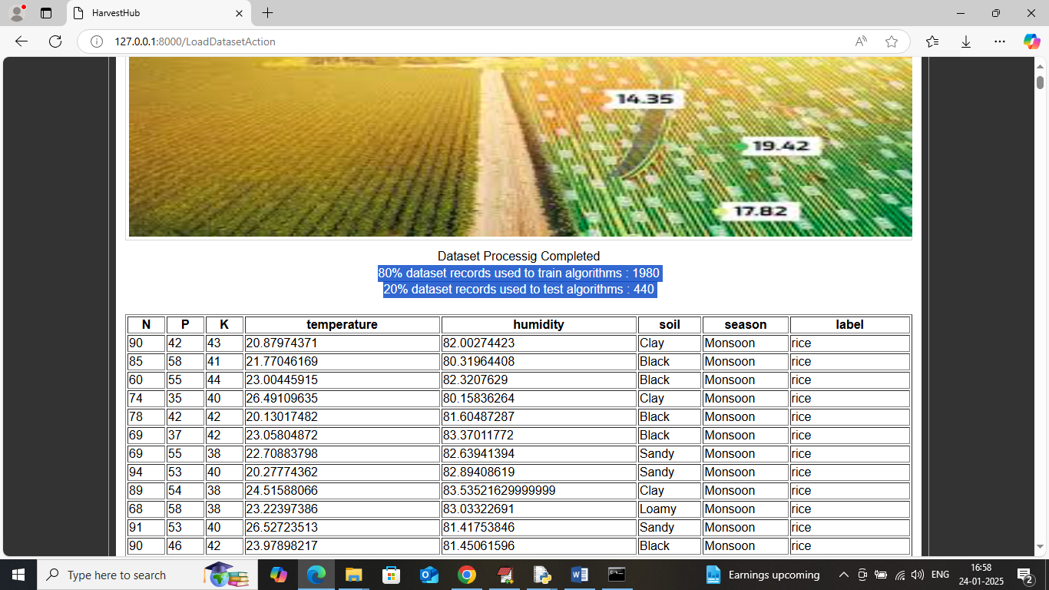

In above screen dataset loaded and can see 80% data is using for training and 20% for testing and now click on ‘Train ML algorithms’ link to get below page

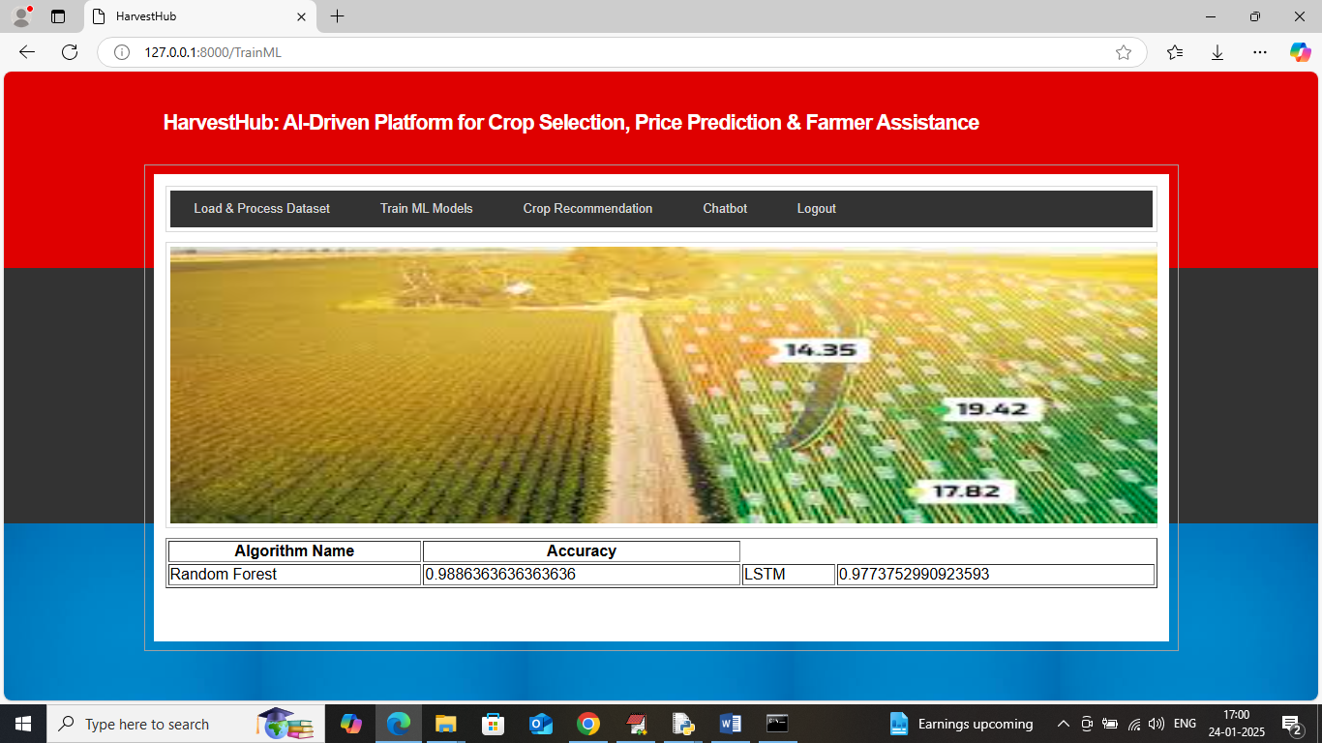

In above screen can see Random Forest and LSTM accuracy where random forest train to predict crop and LSTM train to predict price and now click on ‘Crop Recommendation’ link to get below page

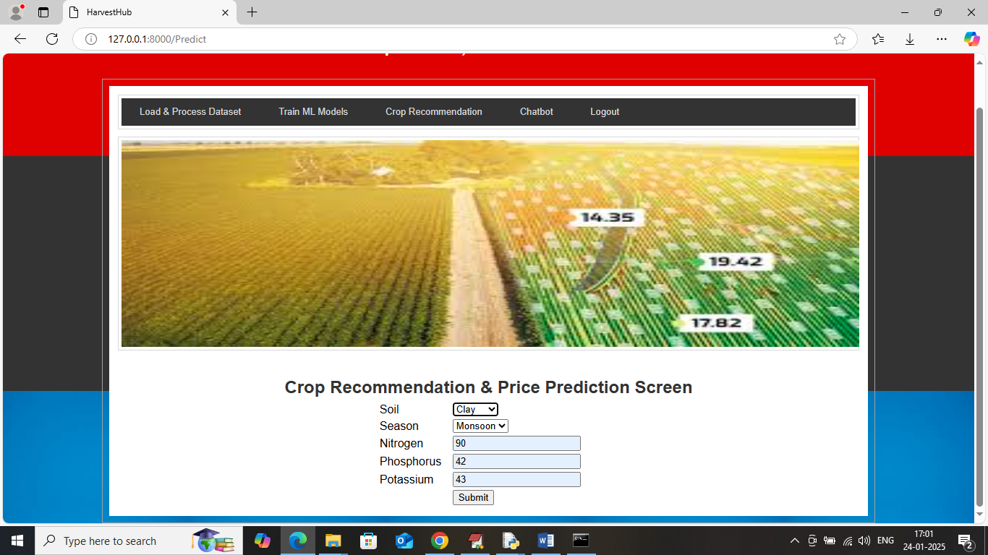

In above screen chose soil and season type and then enter chemical details and then press button to get below page

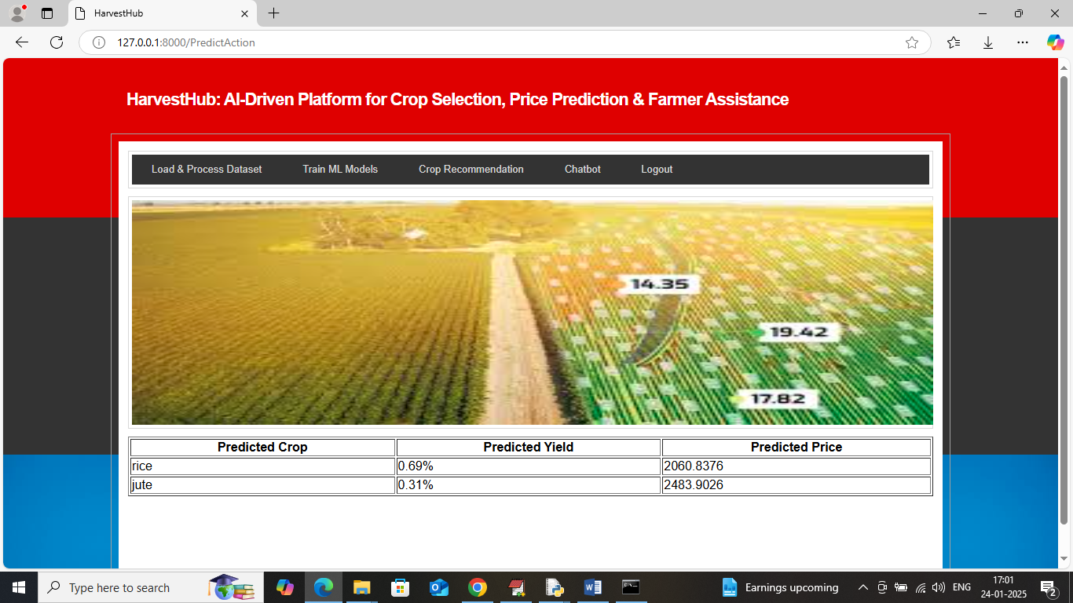

In above screen we got list of suitable crop along with yield percentage and can see predicted prices and similarly you can select any values and get prediction and below is another sample

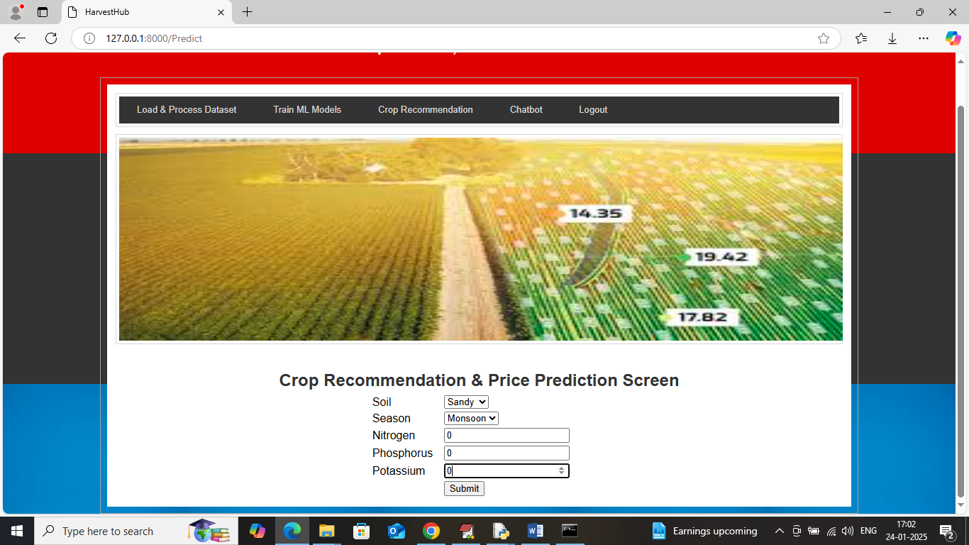

In above screen they can enter 0 for all chemical values if they are inexperienced and can choose only soil and season details and then press button to get below page

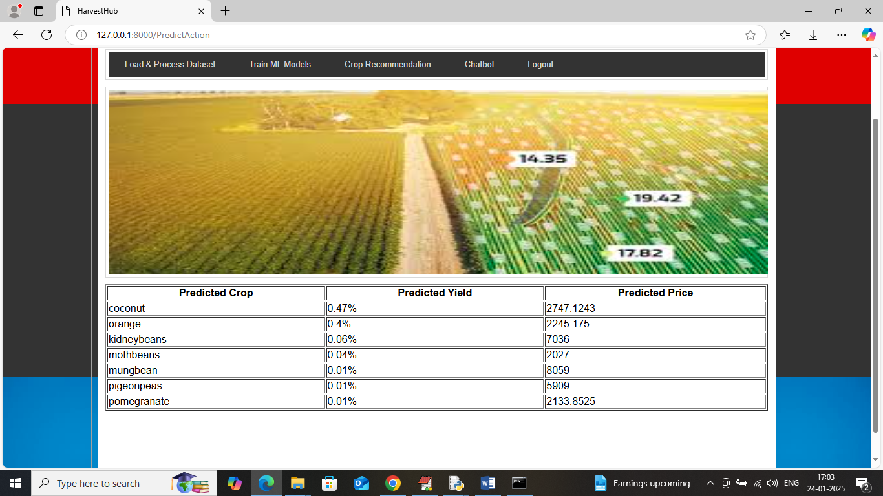

In above screen can see list of crops with yield and price for selected soil and season. Now click on ‘Chatbot’ link to get below page

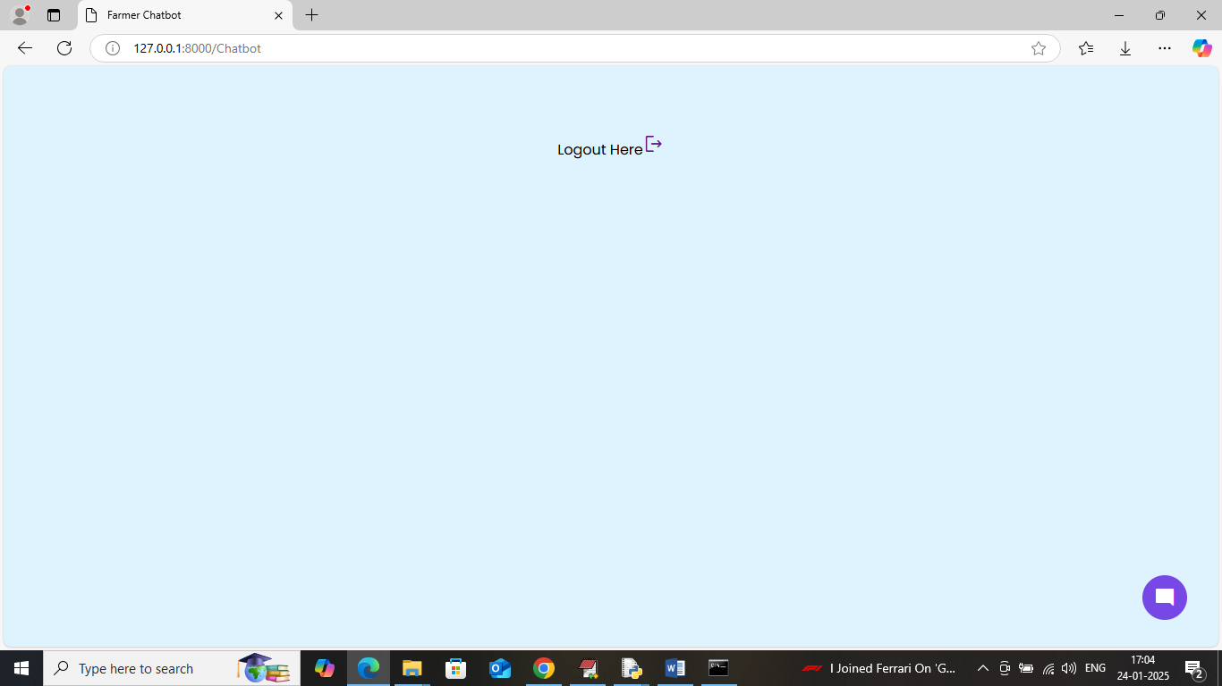

In above screen click bottom ‘blue circle’ to get below page

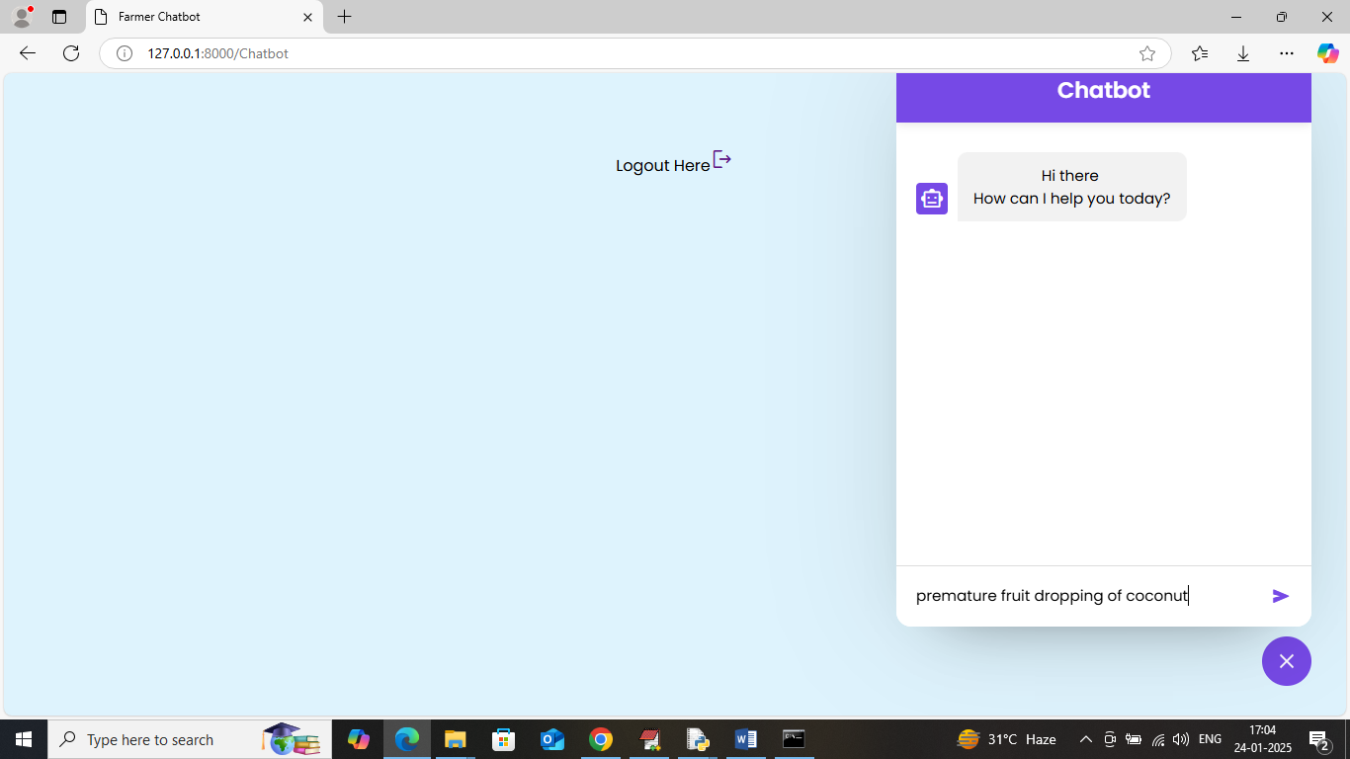

In above screen in bottom text field farmer can enter some query and then press enter key to get below page

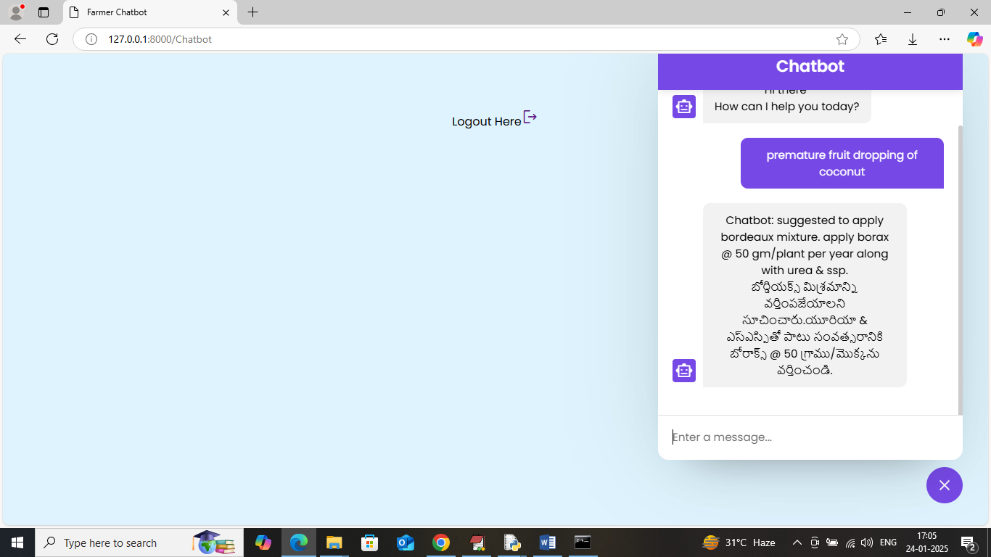

In above screen in blue patch can see farmer question and below that we can see Chatbot reply in English and Telugu language. You can ask any question available in ‘Dataset/question.csv’ file.